**Barnes**

**URL:** barnes..toppromotions.com/store

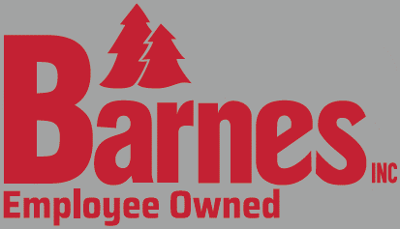

**PMS or Hex color scheme:** Red and White

**Vector Files for Logo’s:**

**Banner:** in drop box

**Footer:** same as every other webstore with Top contact info etc.

**Home Page Text**

ABOVE the categories we’d like the text: NA

BELOW the categories we’d like the text:

“Orders will be accepted until XXX and product will ship by XXX”

Each item is custom made just for you, we appreciate your understanding that returns are not accepted except in the case of defective product.

**Info for “Help” Page**

Customer Service

If you have any questions about your order, please contact Top Promotions at: 608-826-6990 or via e-mail at [webservices@toppromotions.com](mailto:webservices@toppromotions.com). Office hours are Monday-Friday 8am-5pm CST.

Product Delivery:

Product will be delivered to the home office.

Sizing

Each product features a size chart to help you select the size best suitable for you.

Returns/Exchanges

Each item is custom made just for you; we appreciate your understanding that returns are not accepted except in the case of defective product.

Payment

You may pay via credit card when you checkout. Your card will be pre-authorized. The actual charge will be made when the order has shipped.

View our Terms & Conditions <a href="https://www.four51.com/Themes/Custom/cdde0792-3f36-497d-88eb-12c282cba5d2/MonthlySpecials/Terms.pdf" target="_blank">Terms & Conditions</a>

**Other Custom Text Required:**

**View Cart Page: NA**

**Login Page: NA**

**Billing Page**

Credit Cards will be authorized at the time of checkout but will not be charged until your order is completed.

**Password Protected?** No